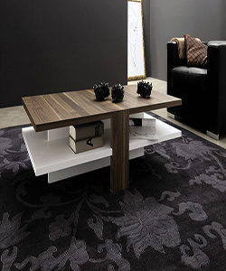

Mecor Coffee Table Design Modern High Gloss White Table of durian

$65.35

Availability: In stock

### Description

• [STURDY AND DURABLE] - Due to the sturdy construction (made of excellent MDF) and smooth high gloss tabletop, the table is durable, and easy to clean with a damp Cloth. The surface is a tempered glass. Upgrade your living room interior with this sleek coffee table in gloss white look and simple design. This table easy to set up, all hardware and detailed instruction are provided; The design of the table is very practical, you can use it as sofa table, side table etc., providing more functions for any space, whether at home or in the office. Hollow design makes better use of storage space, and have two extra drawers.